**Aim: To interface 5 LED’s with Arduino and write a program to blink 6 LEDs, one at a time, in a back and forth formation.**

**THEORY:**

**LED:** In the simplest terms, a light-emitting diode (LED) is a semiconductor device that emits light when an electric current is passed through it.

**RESISTOR:**  A resistor is a passive two-terminal electrical component that implements electrical resistance as a circuit element. In electronic circuits, resistors are used to reduce current flow, adjust signal levels, to divide voltages, bias active elements, and terminate transmission lines, among other uses.

**pinMode():**  The pinMode() function is used to configure a specific pin to behave either as an input or an output.

**digitalWrite():**  The digitalWrite() function is used to write a HIGH or a LOW value to a digital pin. If the pin has been configured as an OUTPUT with pinMode()

**CIRCUIT DIAGRAM:**

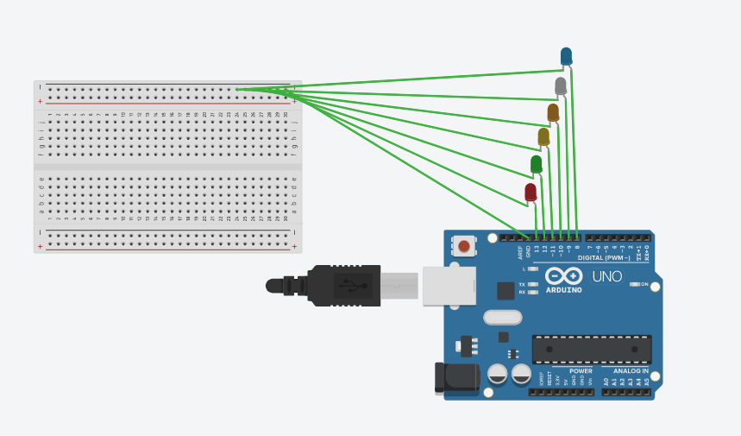

**SOURCE CODE:**

void setup()

{

pinMode(13, OUTPUT);

pinMode(12, OUTPUT);

pinMode(11, OUTPUT);

pinMode(10, OUTPUT);

pinMode(9, OUTPUT);

pinMode(8, OUTPUT);

}

void loop()

{

for(int i=13; i>=8; i--)

{

digitalWrite(i, HIGH);

delay(1000); // Wait for 1000 millisecond(s)

digitalWrite(i, LOW);

delay(1000); // Wait for 1000 millisecond(s)

}

for(int i=9; i<=13; i++)

{

digitalWrite(i, HIGH);

delay(1000); // Wait for 1000 millisecond(s)

digitalWrite(i, LOW);

delay(1000); // Wait for 1000 millisecond(s)

}

}

**OUTPUT:**

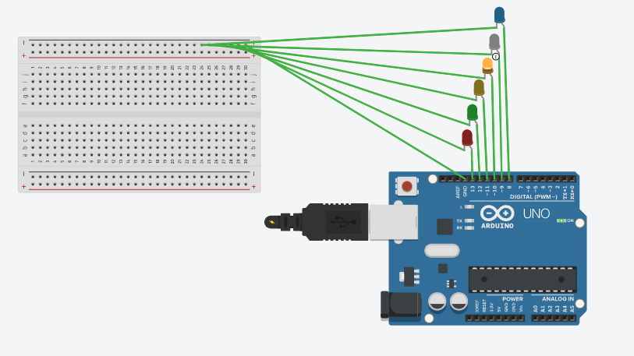

**CONCLUSION:**

Successfully interfaced 5 LED’s with Arduino and programed it to blink 6 LEDs, one at a time, in a back and forth formation